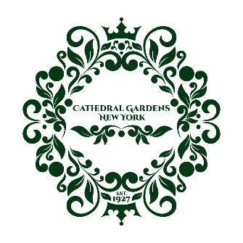

January 2024

Dear Neighbor,

Happy new year! I hope this message finds you well. As the Treasurer of the Cathedral Gardens Civic Association this year, I am reaching out to you today with an important update regarding our Annual Dues Campaign.

As we embark on the journey of the new year together, I invite you to participate in the 2024 community dues campaign by making a donation of $30.00 or any other amount that resonates with you. Your contribution, no matter the amount, will directly impact the success of our civic projects.

Over the years, your contributions have allowed us to organize community events, maintain public spaces, and support local initiatives. So, as we embark on this new year, we are once again calling on your generosity to help us continue our mission.

I understand that times can be challenging, so any support you can provide is greatly appreciated, as it is your commitment to our community that makes it thrive. If making a donation is not feasible for you at the moment, perhaps you'd be interested in joining one of our committees instead? Reach out to us via email or at our next community meeting as we would love to work with you!

Now, let us look back at all the community events and achievements the CGCA accomplished in 2023:

● Coordinated Welcome Wagon to our new neighbors.
● Presented Family Movie Night at the Bedell Avenue Circle.
● Hosted the Fall in Love with your Neighbors event.
- Beautified Cathedral Gardens with hanging flower baskets, Christmas wreaths, & American flags
● Shared civic news on social media and our website
- Celebrated our third Christmas Tree lighting event.
- Conducted our first "Tree Lottery" resulting in the planting of 10 new trees which will beautify our neighborhood for years to come.
This year we aim to do more of the same, and this is why we need your support. To streamline the process, we have set up multiple payment options for your convenience.

Here is how you can contribute:

- Venmo @CathedralGardens-CivicAssociation.
- PayPal (located at www.cathedralgardenscivicassociation.com, click on Membership and then Donate). If choosing this option, please indicate a personal payment rather than a payment for goods and services to avoid the commercial fee.
- Mail check payable to Cathedral Gardens Civic Association and mail to P.O. Box 267 West Hempstead, NY 11552. Please include your name, address, and telephone number on the tear off portion found below.

To express our gratitude, all contributors will be acknowledged on our website under the Membership tab.

If you have any questions or would like more information about our dues campaign, please do not hesitate to contact me at email@cathedralgardenscivicassociation.com or at (516)455-1293.

Thank you in advance for your generosity and continued support. Let’s make this year the best one yet for our community!

With best regards,

Christina McCabe, Treasurer
Cathedral Gardens Civic Association

……………………………………………………………………………………………………… CATHEDRAL GARDENS CIVIC ASSOCIATION 2024 DUES CAMPAIGN

Fill out and return in the enclosed envelope:

MEMBER NAME: ____________________________________________________

ADDRESS: __________________________________________________________

EMAIL ADDRESS: ___________________________________________________

TELEPHONE #: ______________________________________________________

www.cathedralgardenscivicassociation.com

