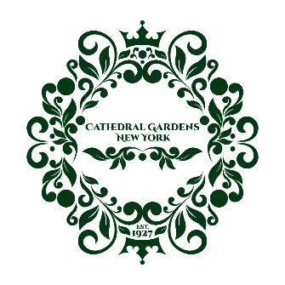

January 2025

Dear Neighbor,

Happy New Year! I hope this message finds you and your family well. As the Treasurer of the Cathedral Gardens Civic Association, I’m reaching out to share an important update about our 2025 Annual Dues Campaign.

As we begin another year together, I invite you to contribute to our community by participating in this year’s campaign. A suggested donation of $30.00—or any amount you feel comfortable giving—can make a meaningful difference in supporting our civic projects. Thanks to your generosity in past years, we’ve been able to organize exciting events, maintain public spaces, and support local initiatives that enhance our neighborhood. As we continue into 2025, your support will help us sustain and expand these efforts.

We understand that not everyone can contribute financially, and that’s okay! If you’d like to get involved in other ways, we’d love for you to join one of our committees. You can reach out to us via email or connect with us at our next community meeting to learn more.

Here are some of the achievements we accomplished together in 2024:

- Welcomed new neighbors with our Coordinated Welcome Wagon.
- Hosted a Family Movie Night at the Bedell Avenue Circle.
- Celebrated the Fall in Love with Your Neighbors event.
- Beautified Cathedral Gardens with hanging flower baskets, wreaths, and American flags.
- Kept neighbors informed via our social media and website.
- Organized our annual Christmas Tree Lighting event with professional carolers.
- Planted 15 new trees through our "Tree Lottery," adding lasting beauty to our neighborhood.

We hope to build on these successes this year, and your support will help make it happen. For your convenience, we’ve provided multiple payment options for contributing to the campaign:

- Venmo: @CathedralGardens-CivicAssociation
- PayPal: Visit www.cathedralgardenscivicassociation.com. Click “Membership,” then “Donate,” and select a personal payment option to avoid commercial fees.
- Mail: Send a check payable to Cathedral Gardens Civic Association to P.O. Box 267, West Hempstead, NY 11552. Please include your name, address, and phone number.

As a token of our appreciation, contributors will be recognized on our website under the Membership tab.

If you have any questions or need further information, please don’t hesitate to reach out to me at email@cathedralgardenscivicassociation.com or (516)455-1293.

Thank you for your continued generosity and support in making our community thrive.

Warm regards,
Christina McCabe
Treasurer, Cathedral Gardens Civic Association

……………………………………………………………………………………………………… CATHEDRAL GARDENS CIVIC ASSOCIATION 2025 DUES CAMPAIGN

Fill out and return in the enclosed envelope:

MEMBER NAME: ____________________________________________________

ADDRESS: __________________________________________________________

EMAIL ADDRESS: ___________________________________________________

TELEPHONE #: ______________________________________________________

www.cathedralgardenscivicassociation.com

